„Cross-border regional green economy model” project
(IPA CBR-GEM, HUSRB/1002/213/050)

Feasibility study summary

Study of the ways of utilisation of renewable energy sources in the
Kecskemét district heating system

Procurer:

Chamber of Commerce and Industry Bács-Kiskun County



Prepared by:

N6 Mérnöki Szolgáltató Bt.
Budapest



30th October, 2012.

Project summary

The Chamber of Commerce and Industry Bács-Kiskun County (CCIBKC) within the frame of the Cross-border regional green economy model project fulfilled by an international cooperation wished to study the opportunities of the region and within this region the possibilities of Kecskemét in order to make use of the opportunities found in the so-called green energy economy development. The CCIBKC worked in close cooperation with the Chamber of Commerce Sombor during this project.

In the first phase of the project a pre-feasibility study was prepared through which the various regional potentials of renewable energy sources were examined along with the technologies of utilization to be thought of, their opportunities and constrains of usability. Because of the priority of district heating utilization, this study did not deal in details with the exploitation of solar energy (proprietorship, operation, problems in connection with measurement, unfavourable experience with FŐTÁV), neither with the utilization of geothermic energy (very low potential in the region). On the other hand, however, the study did have a detailed focus on the exploitation of herbaceous- and wood plants, as well as on the different opportunities of biogas production and utilization (biomass of natural origin and also coming from energy plantations used in heating plants and power houses). Each version was compared on the basis of the thrift studies linked to their investigation.
The study revealed that in the district heating system of Kecskemét the utilization of biomass, and within this the solid biomass could have the best opportunities.

The second phase of the project was to prepare a feasibility study in order to be able to examine the most adequate possibility having a detailed description of the opportunities given.

Considering the versions suggested in the pre-feasibility study, the exploitation of solid biomass in power houses was examined in details as for its greater social effects (employment, qualified workforce need, more complex service needs). Besides this version another power station with lower capacity was also investigated in order to have a better comparison.
Legal and economic environment

The energy- and environment political background of the Kecskemét Bio Powerhouse Project was fundamentally defined by the climate policy of the European Union and the Hungarian politics concerning this issue.

Nowadays it is more and more evident that the further development of human beings is threatened by the clime change. The European Union would like to be the leader power in the fight against climate change. Besides the reasonable sustainability views, the EU realized that the competitiveness of Europe could be much better in a climate aware world, as in a non-climate-aware one. It could be so as Europe possesses few energy sources, but on the other hand Europe has the technologies and the culture needed for the utilization of renewable energy sources, and the efficient energy management. The proverb says: “If you do not have energy, be clever!”, and the EU takes it seriously. The EU formulated concrete energy management goals for 2020, and long-term climate policy plans are also under preparation.

The so-called 20-goals:
- 20% energy efficiency improvement
- 20% emission-reduction
- 20% increase in the rate of using renewably energy sources by 2020.
The political background of the Kecskemét Bio-powerhouse Project determined by the renewable energy goals was split among member states by the EU in the 2009/28/EC directive. The final gross energy consumption goal for Hungary stated in the directive was 13%. The EU listed amongst the competences of the member states to determine the followings:
- how to share the renewable heat, the renewable electrical energy and the renewable engine fuels within the performance of the target goal
- among the utilization categories in what proportion the various renewable technologies should be present (wind, solar energy, biomass, geothermic), in other words what the so-called energy-mix should be.

The National Renewable Action Plan (NRAP) was prepared at the beginning of 2011 on the basis of the expectations of the directive referred to. Against the 13% target for the gross energy consumption assigned in the Action Plan, Hungary set forth the rather ambitious target of 14.65%.

The renewable energy based electricity production turns as follows:
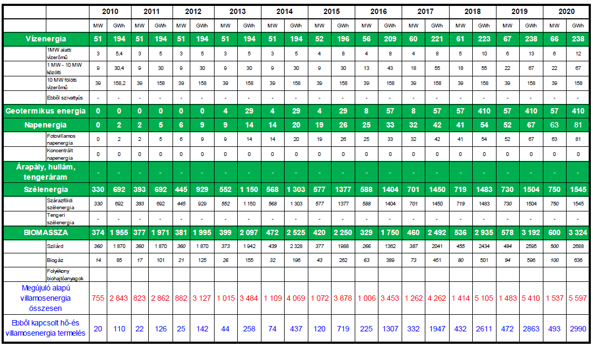

chart 1.
Renewable energy electricity production by 2020
Source: NRAP

It can be seen that according to the NRAP the electrical energy coming from mainly the wind and biomass based renewable energy sources is going to increase significantly (mainly with the spread of wind power. The development of biothermic power stations primarily depends on the availability of biomass ensured for energetic targets. The energetics utilization of biogas and communal waste, and the thermical exploitation of agriculture fossils could mean an increase against the national energetics realization of dendromass (wood).

The situation of energy consumption for cooling and heating based on renewable energies is presented in the following chart in ktoe dimension:

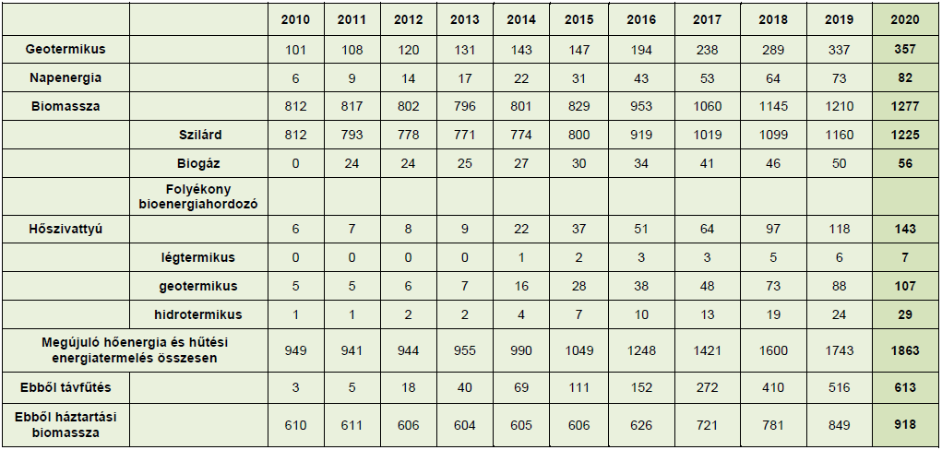
chart 2.
Energy production for cooling and heating based on renewable energy up to 2020
Source: NRAP

According to the figures of NRAP the rate of renewable energy source within the heat market doubles. The district heating system gets an emphasized role within this market (it means that from 18 ktoe it increases to 613 ktoe by 2020), along with the biomass based related energy production (it means that from 25 MW it increases to 493 MW).

Parallel with the appearance of the NRAP the following issues were released in the government’s communication:
- Increasing the heat production on renewable energy basis against electricity production on renewable energy basis. Taking into consideration the tendencies of isolating the buildings and blocks of flats, as well as the physical boundaries of expanding the biomass based heat production among the population, this issue may only be fulfilled if a much greater role is going to be given to the electricity production based on renewable energy sources.
- Rolling back the use of biomass in great power stations. According to the government’s communication the background of this issue is the fact that the government would like to save the wood stands against their bad utilization in great power stations. Another aim could be to release the wood to be used in great power stations in order to let them be used among the population.
- Turning accentuated attention to the community biomass based heat supply, and in the cases of bigger systems with linked heat- and electricity production.
- The use of herbaceous plants or herbaceous and wood plants in new furnaces with higher capacity against the use of only wood plants.
- Applying more severe incentives in establishment producing renewable energy in order to keep the guides.
It can be stated that the planned Kecskemét Bio Power-Station Project corresponds to all of the criteria of the renewable energy policy, and it can be seen that among the set targets the biomass based linked energy production gets an emphasized role within the community heat production.
In order to keep the aims set before the Government is going to apply the followings:
- Changing the so-called KÁT system, launching the METÁR system
The KÁT system is going to be used for supporting more efficiently the real renewable energy production besides gradually decreasing the support of gas-based energy production. In the process of the system change the price of the biomass based electricity is going to be determined in such a way that it could cover the costs of production as well as the expected profit of the investors. The experts of the Hungarian Energy Office (HEO) already prepared calculations concerning the prices. The results can be found in the following chart:

Suggested average prices to receive for condensation biomass-fired power stations,
on price levels in 2010, Ft/kWh [MEH]
Performance category | 1-5 MW | 5-10 MW | 10-20 MW
Prices to receive with wood plants | 40,8 | 26,4 | N/A
Prices to receive with herbaceous plants | N/A | 30,6 | N/A
chart 3.
Planned prices to receive for condensation biomass-fired power stations
Source: HEO

Suggested average prices to receive for biomass-fired power stations with linked energy production on price levels in 2010, Ft/kWh [MEH]
Performance category | 1-5 MW | 5-10 MW | 10-20 MW
Prices to receive with wood plants | 44,9 | 29,3 | 22,3
Prices to receive with herbaceous plants | N/A | 35,6 | 25,0

chart 4.
Planned prices to receive for condensation biomass-fired power stations
Source: HEO

It would be worth comparing the prices in Hungary with the prices of neighbouring countries. Amongst the countries of this territory the price of biomass is relatively the same, as such the investors could get on the same price level to the installations for the technology, and also the costs of the employees are almost the same in the neighbouring countries. Maybe Romania could be an exception as the prices of the biomass there as well as the costs of the employees may be a bit lower than in the other countries. According to the comparison the prices in Hungary are 20-40% lower than in the neighbouring countries concerning the prices of green energy.
Underestimating the prices of green energy would lead to making the renewable energy target unattainable, and it could also procure the export of the Hungarian biomass. It would mean that the Hungarian raw material is used for the production of green energy in other countries.

Operating the investment support system
The Government is expected to ensure investment support to improve renewable energy policy projects from November 2012, within KEOP Project 4.

Simplifying the licensing procedure
As the survey carried out by the Energy Club revealed, the Hungarian system for licensing renewable energy production projects is rather complex, bureaucratic and its is expensive for users. The simplification of the system with lower prices is being planned. However, the change within the procedure is going to take a bit longer as several laws need to be changed by that time.

Preparing the agriculture energy program
The Government’s communication formulated the need of preparing the agriculture energy program, and it also referred to some main directions. Among the main issues the more efficient support of energy plants is surely going to be present along with the simplification of agriculture by-products in energetics usage.

Information and education
According the communication, the Government would like to improve the information and educational background of the utilization of renewable energy sources. In the case of such a will of the Government, the Kecskemét Bioenergy Project could make a profit from the fact that for the operators of the future heating power stations it could offer support for their education.

Technical background of the project
The greatest customer of the biomass-fired heating power station is the Kecskemét local district heating system. The system has two heating districts: the Széchenyiváros district (heating provided by the heating plant in Akadémia krt.), and the Árpádváros district (heating provided by the heating plant in Szultán street). The loading diagram of the districts can be followed in the chart below:
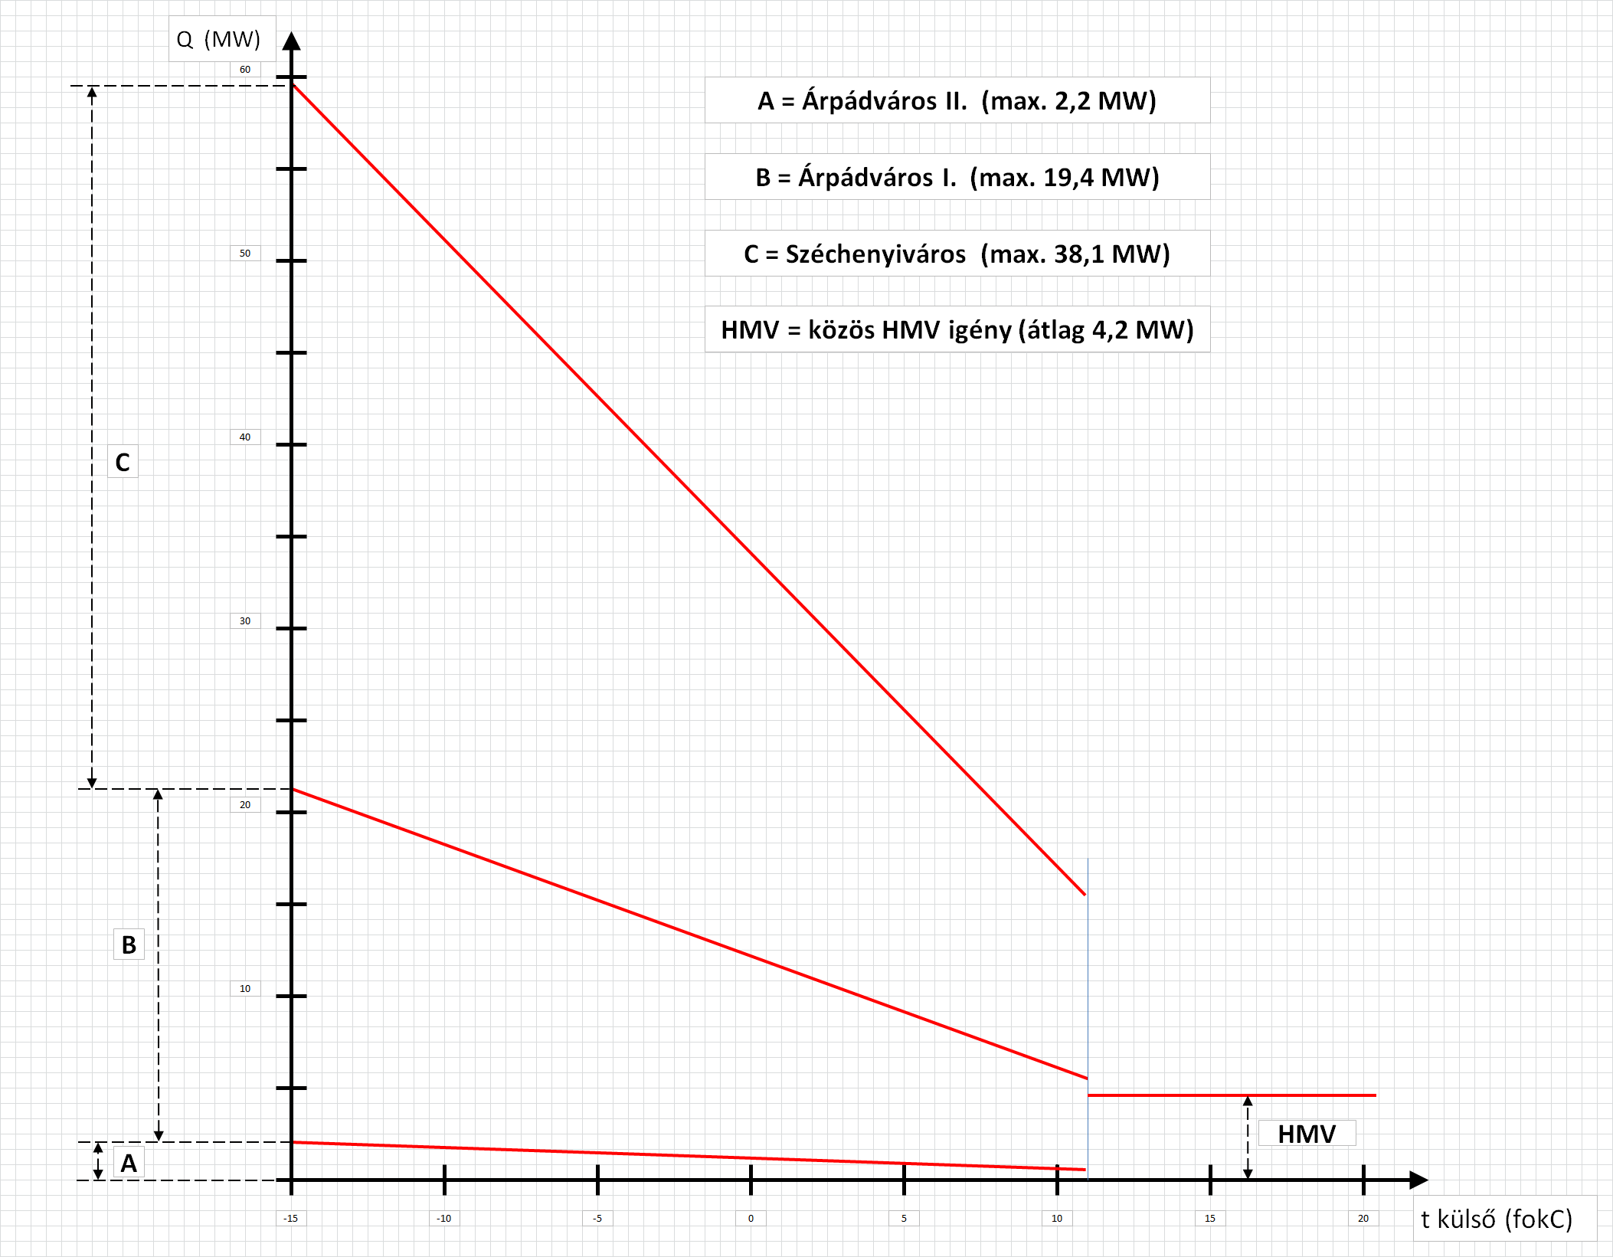

chart 5.
Loading diagram of Kecskemét district heating system

Széchenyiváros: The heating plant in Akadémia krt. 4. provides the 2/3 of the overall district heating customers, meaning 7,471 apartments.
This heating plant has been operating since 1975, and the district heating is 100% self produced. The heating sources are gas-fired hot water furnaces with a heat performance of
62,5 MW. Between 2011-2003 three JENBACHER gas-engines were installed, which could provide the hot water need of the whole housing estate during the summer period. The electrical output of the installations is altogether 4.7 MW, the heat out is 5 MW.

Árpádváros: The heating plant in Szultán street 1. provides the district heating for the Árpádváros district, as well as 3,763 apartments in the central of the town, and also for hundreds of other customers all over the town.
This plant was founded in 1898 for producing electrical energy, but its function changed gradually. Along with the decrease of the production of electrical energy, the significance of the district heating system increased. The heating performance of the hot water and warm water furnaces is 31.2 MW. A 1.5 MW electrical and a 1.6 MW heat performance JENBACHER gas-engine ensure the warm water heat needs during summer, and the preheating of the back-up primer heating water.
The overall heat need of Kecskemét district heating system in 2009 was 405.167 GJ/year.
In order to have a better utilization of the two district heating plants, these are going to be connected with each other, and thus the size of the power stations were taken into consideration. The track of the linking pipeline system is of “U” shape with a length of 1750m.

Electrical energy usage
The energy being produced is planned to be provided by the DÉMÁSZ Hálózati Elosztó Kft. through a 132kV cabel, which is in the property of the power station. The power connection to the grid can be either in Kecskemét, Szultán street with 120/20/10kV substation, or at Városföld 120/35kV substation.

The power station
The connection to the district heating system is planned to be at Szultán street heating plant, where a new heat supply station is needed to be constructed. This would include a 22 MW heat exchanger, circulation pumps, make-up water pumps and a make-up water tank with deaerator. The heat supply station is of biomass-fired base with irradiating firebox, cooling, fluidised-bedded, and on the steam and water side it is of tradition steam cycle in order to produce the propelling steam of the turbine. The firing system enables the furnace to work efficiently in order to reach a relatively fast changing in charging and get the right emission rates. The primers are of gas-fired. 2 primers are going to be installed, each of 4 MW power.

The nominal parameters of the main steam valve at the exit:
Steam power: 40 t/h
Temperature of the exit steam: 495 °C
Pressure of the exit steam: 68 bar(a)
Efficiency: 89%
Nominal temperature of the water: 134 ºC

The regulatory system of the heat supply system is built in the right deepness in order to totally regulate the heat supply system, and it also includes every installation of the regulatory and safety system.
The smoke is being cleaned by a dust cleaning system, which is built in at the back of the heat supply system. This dust cleaning system is working on the principle of electrostatic or on the so-called pocket principle.

Main technical data of the turbo machine group
Heat lap 40 t/h
Temperature of the incoming steam 494 °C
Pressure of the incoming steam 68 bar(a)
Take away pressure 3,6 bar(a)
Max. take away steam energy 35,8 t/h
Nominal exit steam pressure in the planning phase 74 mbar(a)
Nominal power 9,95 MW

The Heller-type dry cooling system is going to be used in order to reduce water demand. This system is mainly installed in such areas where there is less water supply, as for its closed system it practically does not use water for its operation.
Main parameters:
Outer temperature of sizing 11 °C
Nominal pressure on the outer temperature of sizing 74 mbar(a)
Cooling power on the outer temperature of sizing 21,0 MW

Water supply
The communal water need of the power plant is about 2.5 m³/day. This amount is available from the system of pubic utility. The ensure the technological water need, one or more wells need to be established.

Technological water needs of the power plant:
- Boiler spare feedwater 0,6 m³/h
- Wet auxiliary cooling 1,0 m³/h
- Wetting ashes 1,5 m³/h
- Self consuming of water plant 1,8 m³/h
4,9 m³/h

District heating spare water: 12 m³/day
Capacity need of the well with safety: 20 m³/h

Controlling system
The power station is installed with a modern controlling system, which ensures that the operation is run according to the safety requirements, on an economical level with minimal staff working by. Every essential technological installation is automatic, the operator only needs to monitor, check and fulfil the planned maintenance procedures. The only field to have a more complex task of the operator is the straw container. The movement of the quantity of the fuel is planned to be delivered with the help of a semi-automatic equipment, and thus the operator needs only to make manipulative tasks.
The controlling system monitors the following installations:
- biomass-fired boiler ,
- steam turbine, generator,
- straw container,
- wood place,
- water operator,
- cooling system,
- energy system.

Maintenance concept
The main installations are going to be operated mainly from the DCS operating station. The following installations have their own process control system, which is linked to the DCS system:
- steam turbine,
- straw container,
- wood place,
- water supply operator,
- cooling system.

The DCS system has the following subfields:
- Process stations and the different systems that are joined to them.
- Process bus.
- Operator stations.
- Engineering stations.
- Network printers.

The process stations and the systems directly joined to them perform the control, the regulation and the protection of the installations. Processor cards, communication cards, normal in-and output card can be found in the process stations.
The operator stations perform the editing, and the different operation tasks can be fulfilled through these stations. Each operator station contains 2-2 monitors, 1-1 keyboard and 1-1 mouse. Printers are directly linked to the terminal buses.
The configuration of process and operator stations, the alteration of programs, and their downloading to the process stations can be performed via the engineering stations. The engineering station is linked to the system bus.
Controlling technologies of the systems

The biomass-fired boiler does not possess an own controlling system. The protection of the boiler and the fire control of the primers is fulfilled by the safety control equipment installed by the boiler supplier. This equipment is in serial connection with the DCS. All the other controlling and regulatory tasks of the boiler are delivered by the DCS, too. The maintenance and editing functions of the safety control system delivered by the boiler supplier are also fulfilled by the DCS.
Concerning the installation of the system, the operator stations as well as the operator workplaces are going to be set in the block controlling room. The fire alarm system and the communication installations are also planned to be in this place.

In the case of normal engines the following parts are in the local operating boxes:
- Safety switch.
- Local / distant switch with key to enable local operation.
- Start switch.
- Stop switch.
- On lamp.
- Off lamp.
- Failure lamp.

In the case of frequency changed engines the following parts are in the local operating boxes:
- Safety switch.
- Local / distant switch with key to enable local operation.
- Start switch.
- Stop switch.
- On lamp.
- Off lamp.
- Failure lamp.
- Tachometer.
- Up switch.
- Down switch.
Open-close valves:
- Local / distant switch with key to enable local operation.
- Open switch.
- Close switch.
- On lamp.
- Off lamp
- Failure lamp.

Regulating valves:
- Local / distant switch with key to enable local operation.
- Open switch.
- Close switch.
- Failure lamp.
- Valves position signal.
- Regulated parameter signal
Regarding the biomass fuel, it may be stated that the fuel of biomass-fired boilers could be mainly wood plants or herbaceous plants. In the case of wood plants the energy production is thought to be a bit better than with only herbaceous plants. However, as for the geographical features of Kecskemét the joint usage of the herbaceous plants and wood plants is recommended.
Considerable solid biomass potential is present in the region. Even with conservative assumptions, almost 40,000 ha of maize and more than 50,000 ha of wheat can be taken as safe source of more than 170,000 tons of biomass. According to statistical data, large afforested areas are available in the region. Based on the wood-yield data of other countries, only Bács-Kiskun county is capable of providing the necessary wood fuel. Additional wood could be available from the neighbouring Pest county.
The potential of the agriculture by-product needed for the operation of the biomass-fired station is explained in annex 1. and 2, regarding wheat and maize. During the analyses a conservative approach was followed, which means that it was examined whether at the lowest quantities of cultivation the fuel supply of the biomass fired station is still assured.
On the course of the supply planning the lowest harvested quantity so far was taken into consideration. The analyses were carried out on regional level, so the neighbouring counties were regarded as potentials, too. The amount of the biomass available comes from the product of the territories and harvest average. Regarding the global warming, a further 20% failure is considered. The available biomass amount is the following:

Maize | 81.837
Wheat | 91.499
Sum: | 173.336

Chart 6.
Available biomass (t/year)

Potentials about wood plant biomass cannot be found among the data of the Central Statistics Office. However, the territories available for forestry are being presented in the following chart:
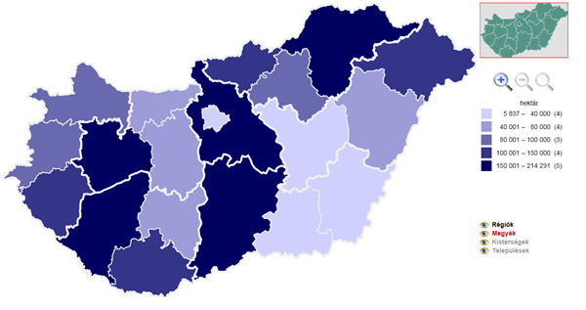
Bács-Kiskun:
180.563 ha
Hajdú-Bihar:
71.335 ha
Szabolcs-Saztmár-Bereg:
122.621 ha

Chart 7.
Forestry territories in the referential counties
Source: CSO
As it may be seen from the chart, the amount of wood plant biomass could be purchased from the county as well as from the neighbouring counties.

As far as the price of the biomass is concerned, the price of the wood chops in the national market is 12,000 Ft/t, which is 1,100Ft/GJ as heating value. On the western part of the country these prices are a bit higher as the Austrian market is too close to the Hungarian one. The price of the herbaceous plants in baler form is 16,000 Ft / t, which is 1,150 Ft/GJ as heating value. More concrete prices could be achieved if the owner of the power station is going to lead trade meetings in connection with these purchases.

Location of the plant
Considering the requirements against the location of the plant, it is clear that it needs to be set in such a place where there is a territory big enough for the power station as well as its installations, and the containers for the biomass fuel. It is also inevitable to choose such a place, which has a good infrastructure for the logistics of the fuel. All the necessary energy sources are very important to be in the nearby, along with the fact that the territory should have all the licenses needed to start the operation. No building societies should be in the close distance. The Industry Park I. in Kecskemét seems to be a good location for the proposed plant as it meets most of the general requirements set against the opening of the plant. There is ample distance from inhabited areas, there is also good road communication thus the logistics could be delivered in quiet an easy way, and the access to utilities is again good.
The arrangement and layout of the plant are also very important factors to be considered. The major structures are the main building, the boiler building, the turbine hall and auxiliary buildings, the electrostatic precipitator, the chimney, the cooling tower, the water treatment plant, the fuel containers and woodyard.
The environment protection regulations, such as the quality of the air, water protection, noise control, waste discharge and possible natural disaster hazards are also deeply and widely examined in the study.

Costs calculation
On the basis of similar plants using biomass straw and maize as fuel, the investment costs of the biomass-fired plant is 11,500 M Ft. The investment cost of the pipeline to be provided between the Széchenyiváros district and the Szultán street plant is 630 M Ft. The investment costs of the pipeline between the biomass-fired plant and the Szultán street plant is 1,332 M Ft. The price of the land on which the installations are going to be set is approximately 250 M Ft. The investment costs of the power connection is an estimated 500 M Ft. Considering 5% spare, the total cost of the project is an estimated 15,343 M Ft. At the moment there is no tender for financially support the production of electrical energy with linked heat-, electrical energy and bio methane on renewable energy basis.

The fuel of the biomass-fired plant is a mix of straw, wood chops and maize stem. To start the boiler fuel, PB gas or gas is needed. The use of gas is not very economical, as only little amount is needed, but the basic fee is too high. According to the experiences of other projects in this topic, the use of fuel and PB-gas is a better option for starting the boiler.
The cost of ash discharge turns as follows: ash content of straw is 5.1 tm%, ash content of maize stem is 9.1 tm%, ash content of wood chops is 2.7 tm%. Considering the utilization of 40% straw, 40% maize stem és 20% wood chops, the total ash content could be 4,370 t/year. The cost of ash discharge is 8,000 Ft/t.
The water need of the power station is 4.9 m³/h that is 38.710 m³/year. It would be wise to ensure the water needs from an own well, and thus the total costs of water station and diversion could be 200 Ft/ m³.
Considering the general costs of the company, it could be 1.5% of the revenues. The operation and maintenance costs are 2.5% of the investment costs, which includes the great reparation costs due in every five years. The cost of the insurance is 2% of the investments cost per year.
According to the law C. from 1990, the local business tax is the margin of the revenues and material costs, which is 2% per year.
Regarding the wage and additional costs 40 employees are counted with a 2.5 M Ft / person average gross wage per annum and 33% additional costs.

Revenues
According to the Government decree 389/2007 the receiving of the electrical energy produced with the help of renewable energy is compulsory and its prices are supported (KÁT system). Based on the decree the prices are as follows:

Period | Receiving price  [Ft/kWh]
High time | 34,31
Valley | 30,71
Deep valley | 12,53
Average | 29,48

Chart 8.
Compulsory receiving prices

At present the unfavourable business environment resulted in the fact that there has not been fulfilled any bio-power station building, and neither there is investment in any besides the Power station in Szakoly. This business environment could be altered in a positive way if the receiving price of the green energy is going to be increased.
At this point the hope is that the compulsory receiving prices is going to endure in a short and medium-term time in line with the practices of most of the European countries. The receiving price of the green energy should give a cover for the costs of the producers, including the costs of the capital, too. This study recommends receiving prices for several renewable technologies and plant size. The relevant receiving price from the point of view of this study is 35.6 Ft /kWh for herbaceous biomass fired plants. This price level is of 2010. Considering the inflation in 2010 and 2011 with 4.6% and 3.9 %, there is a hope of a 38.69 Ft /kWh receiving price.

The process of the project realization
The concept of the project has already been done, and within this the possibilities of the fuels to be used, the technology, the power and the services have been chosen. Preliminary business calculations have again been delivered. The present study provides an answer for the expected thrift, and it also gives an opportunity to have a sample for the further developments.
The location has already been chosen along with the examination of the potential fuel basis. The project development is one of the most important tasks to be considered having in mind the followings:
- setting the ownership frame. In most cases a project company is established, which is going to be the owner,
- setting the circle of the owners – e.g. to what extent private capital should be taken in -, and also the ratio of ownership,
- setting the boundaries of the project tasks (e.g. only the power station should be part of the project, or any field of the fuel supply tasks),
- the position of the contractual – business – partners, the content, mode and length of the agreement,
- setting the mode of financing the realization, in case if a credit is going to be taken then the assurance of the own portion,
- setting the mode of the project control during the construction and operation period,
- setting the structure of the execution and operation.

The structure may be altered during the advancement of the project. It is advisable to make a decision within the frame of the structuring on how to ensure the cover of the development costs.

In the course of the purchasing of fuels, the delivery offers need to be examined, a meeting needs to be arranged with the suppliers, and then a long-term fuel delivery agreement should be signed.
The decision about the investor of the project should be made and it needs to be set clear what kind of purchasing is going to be used.
It is inevitably important that the investor possesses the ownership of the construction site in time. As the territory is of industrial park labelling, requalification is not needed.
The plans of the establishment need to be prepared, on a so-called basic design level. The preliminary estimated costs of preparing the plans could be of approximately 1% of the investment costs. The basic design covers the following fields:
- technologies,
- landscaping, diversion of rain,
- joining to the district heating
- joining to the electrical network
- water supply
- sewage disposal
- landscape arrangement
- construction
- environment protection
- fuel transportation
- power station electrical power take over
- controlling.

The basic design on one hand is really good for underpinning the investor’s decisions, and on the other hand it could be a basis for tenders of financing, supplier tenders, and also for preparing the licensing documentation.
Subject to the supplier model, it could be subservient to launch tenders for main equipments in order to make it clear what kind of installations could be purchased with what type of conditions. No main equipment tender is needed if the investor would like to fulfil the realization of the establishment with a main contractor.
During the process of licensing, the following tasks should be taken into consideration:
- preparing the optimal licensing strategy,
- setting the circle of permissions needed for the financial closing, magisterial consultations,
- putting together the licensing documentation,
- handling the process of licensing.

After the successful fulfilment of licensing, all the permissions are at hand, which are inevitable for closing the banking. More permission is needed to be purchased in the period of construction.
The condition of financial closing is the realization, operational, fuel transportation and advisory contracting. These contracts could be signed after arranging adequate competitive bidding, launching tenders, and call for public procurement procedures. Setting the right contracting structure could extremely simplify the investor’s work. In case of public procurement procedure the launch of tenders may be realized after ensuring the financial support.
In order to have fruitful meetings with the financial partners, the owners of the project should prepare a financial memorandum, and as the background of it, a data room should be put together. The memorandum typically contains the following documentations:
- audited business plan,
- permissions,
- main contractor and operational contracts,
- fuel transportation contracts,
- heat-, and electrical energy sales contracts,
- documents to prove the own financial support,
- the so-called zero report of the independent engineer,
- company’s documentation proving the existence of the credit and its financial suitability, and other documents.

After having finished the above mentioned tasks, the owner of the project could lead meaningful meeting with financial institutions ready to take part in the support of the project. Of course, the own financial support is inevitable, and it is also one of the requirements of the launch of the project. It is a strategic question whether the leader of the project would like to use any tender support or not. If they wish to, then the procedures of tendering should be delivered. One of the conditions of the credit support is the presence of the own and tender support.
After successfully finishing the financial meetings, the documentations of financing should be singed, and the launch of the construction of the project could start.
When the construction of the project has been fulfilled and the establishment has been handed over, the dry runs may be started. The dry run is controlled by the main contractor; however the operation is usually delivered by the personnel. This is essential in order to have an overall check of the operational procedures and the technical procedures connected to the establishment.
During the dry runs the investor needs to purchase all the permissions for operation as well as the contracting with the utility companies should be signed in order to be able to start to real operation.

Among the subsidiary effects of the project the impact of employment is one of the most important. The planned biomass-fired plant is going to offer workplaces within the company, but also for entrepreneurs providing the facility management of the plant. The direct employment means the employment of the operational personnel of the power station. Taking into account the three-shift to be introduced at the plant as well as the specialities of the different fields, the number of employees may be expected to be about 40-45 people. Regarding the technical world of today, less employees would be also enough to run the plant. In order to introduce this, a significant investment is needed, which is not really reasonable within the national labour market.
Indirect employment may be present in the following fields:
- fuel supply
- transportation tasks
- maintenance services
- labour-, fire service, and health care services
- environment services
- magisterial services
- financial and bank services

The biomass project has a stirring effect on the local economy. The number of indirect employment may be estimated with 150-200 people. Moreover, if the gardening field is also taken into consideration, another great proportion of the employment may be expected.
The workforce needed by the biomass-fired plant could be rated in three categories. People with higher education, possessing one or two degrees are needed in the top management of the company. Employees are expected as:
- power station executive
- economy / financial executive
- technical executive
- HR, environment protection, fire service, labour safety referent.
The legal and accounting field may be executed by either own employees or external partners.
The operational staff needs to have the basic educational level assigned in the regulations and decrees, as well as special qualifications needed by the specialities of the biomass-fired plant. The latter is ensured by the main contractor in the meantime of the installation of the plant.
Some of the most important professions:
- stoker
- Energy plant steam turbine operator
- Energy plant sub-machinery operator
- Energy plant operator (low-, middle and strong current) 3/1981. (V.6.)IpM-MüM
- Energy plant water preparation operator
- Pressure container operator
- Electrical machinery and installation operator / technician
- Laboratory technician (or chemists)
- Strong current and low current electrician
- Engine fitter
- Logistic operator
In the department of fuel container and facility support only trained personnel is needed.

As far as the new market opportunities are concerned, during the preparation period, planning phase and construction of the establishment, several services are going to be required, mainly the followings:
- Project development services, which need mechanical, electrical, control and construction engineering as well as business analysts,
- planning and licensing services, which require engineers from the different professional fields,
- equipment manufacturing (unfortunately in the present situation of the Hungarian energetics equipment manufacturing market, only a little proportion of the biomass power station equipments may be manufactured in Hungary. Most of these equipments need to be imported),
- construction works
- rigging works
- environment, quality management, labour and fire safety services
- company organisation and project management
Altogether it may mean more than hundred people. The number of people employees during the construction period may reach the 200 members.

Cooperation of the power station with a gardening project
The planned power station works on the principle of condensation steam turbine, which enables a linked energy production. Because of the unavoidable condensation, waste heat appears in each production phase. The more heat is produced by the power station for district heating, the less waste heat appears in the main cooling systems of the power station. It improves the efficiency of the project in case if at least a part of the waste heat is being sold.
The waste heat is present in the main cooling system on a temperature of 30 °C during winter time and 40-50 °C during summer time. Such low temperature heat source cannot be used for providing heat for usual consumers. On the other hand however Hungarian experts developed such a gardening greenhouse technology, which could perfectly utilize the heat with low temperature. The Ecofinance Ltd. Possesses the technology of using heat blankets. The picture of the heat blanket and the photo of an operational procedure are being presented below:

Chart 1.
Heat blanket

Chart 2.
Greenhouse heated by heat blankets

There are several advantages of using heat blankets in order to heat greenhouses. The heat need is much lower than in the ones heated with the traditional technology as the introduction of heat to the plants is very close.
At the same time favourable agro-technical advantages appear:
- the plants receive the heating from below, party with radiation, and as such the leaves remain dry and the fungus disease decreases,
- because of the radiating heating the temperature of the plants are higher than the surrounding air, and as such the migration of bugs is also lower.

Risk study

The main strength of the planned project is that
- it assures a solution for providing a significant proportion of the heating needs of Kecskemét district heating on non-fossil basis, and
- it contributes to achieve Hungary’s goal in climate protection.

The weakness of the project is that it needs a significant investment source for implementation. The organization of financing this project is one of the greatest challenge of the developers.
On the other hand, however, the project has several opportunities:
- it assures possibilities for the agricultural and forestry entrepreneurs of the region to sell their biomass products ready for being used as fuels on a stable market,
- it assures possibilities for other companies to give services in the course of the building phase, then during the service period,
- it enables the town Kecskemét to integrate modern technologies in the local society with yet another new field of the renewable energy production,
- at last, it enables the employees of the area to get workplaces in the power station, or at their service provider departments.

Of course, the project has some risks, which could be divided into external and internal ones.
Among the external risk factors it could be mentioned the changing in the legal and regulatory systems, and also the general economic environment. As it has already been mentioned before, the regulatory system of the renewable energy production in Hungary has not been developed yet. Further steps need to be taken in this field.
Among the internal risks the followings may be mentioned:
- the installation of the power station is realised after the expected period and above the costs set previously , and also with lower technical performance – the responsibilities of these risks may be shifted to the main contractor,
- the fuel suppliers, who have long-term contracts with the power station during the development period, do not fulfil their responsibilities. In order to handle this problem, a greater fuel supplier capacity is needed,
- during the operation the expected financial performances do not appear. One way to solve this problem could be the professional operation of the plant, and the training of the operator staff,
- damage due to natural disaster. To handle this problem, insurances need to be made.

